

Name : Alveena naz
registration number : fa25-bse-010
pf lab assignment 2

Q.1
import java.util.Scanner;
public class FirstJava
{
public static void main(String[] args)
{
Scanner input = new Scanner(System.in);
char ch;

do
{
System.out.println(" Enter a number between(1 to 5) for pattern");
int pattern = input.nextInt();
switch(pattern)
{
case 1:
int n = 4;
for(int i = 0; i < n ; i++)
{
for(int j = 0; j <10; j++)
{
System.out.print("*");
}
System.out.println();
}
break;
case 2:
n = 5;
for(int i = 0; i < n ; i++)
{
for(int j = 0; j <i+1; j++)
{
System.out.print("*");
}
System.out.println();
}
break;
case 3:
n = 5;
for(int i = 0; i < n ; i++)
{
for(int j = 0; j < n -i -1; j++)
{
System.out.print(" ");

}
for(int k = 0; k < i +1; k++)
{
System.out.print("*");
}
System.out.println();
}
break;
case 4:
n = 5;
for(int i = 0; i < n ; i++)
{
for(int j = 0; j < n -i -1; j++)
{
System.out.print(" ");

}
for(int k = 0; k < (2 *i +1); k++)
{
System.out.print("*");
}
System.out.println();
}
break;
case 5:
n = 5;
for(int i = 0; i < n ; i++)
{
for(int j =0; j <n-i-1; j++)
{
System.out.print(" ");

}
for(int k =1; k <=(2 * i +1); k++)
{
System.out.print(i+1);
}
System.out.println();
}
break;
default: System.out.println(" Invalid choice! please enter between 1 and 5:");
}

System.out.println(" Do u want to perform the operation again? (y /n)");
String choice = input.next();
ch = choice.charAt(0);
}while(ch== 'y' || ch=='Y');

System.out.println(" Programme terminated");

}
}

OUTPUT:
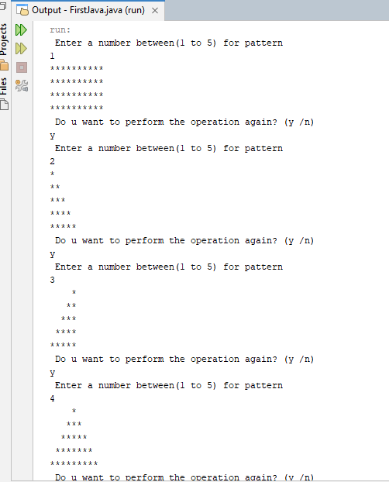

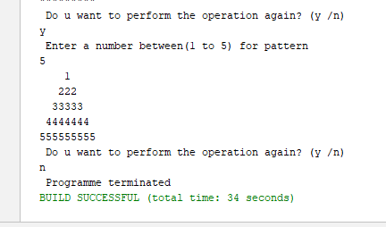

Question 2:
import java.util.Scanner;
public class FirstJava
{
public static void main(String[] args)
{
Scanner input = new Scanner(System.in);
System.out.println(" Enter your sequence that ends with zero");
int num = input.nextInt();
int greater = 0;
int count = 0;

while(num!=0)
{
greater = num;
num = input.nextInt();

if(num > greater)
count++;
}
System.out.println(count);

}

}

OUTPUT:

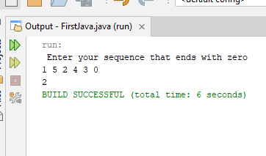

Question 3:
import java.util.Scanner;
public class FirstJava
{
public static void main(String[] args)
{
Scanner input = new Scanner(System.in);
System.out.println(" Enter number ");
int n = input.nextInt();
int fact= 1;

for(int i = 1; i <=n; i++)
{
fact*=i;
}
System.out.println(" The factorial of number is " + fact);

}

}

OUTPUT:
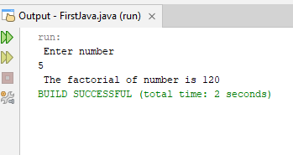

Question 4:
import java.util.Scanner;
public class FirstJava
{
public static void main(String[] args)
{
Scanner input = new Scanner(System.in);
System.out.println(" Enter a string ");
String word = input.next();
char first =word.charAt(0);
char last = word.charAt(word.length()-1);

if(first==last)
System.out.println(word + " is a Palidrome");
else
System.out.println(word + " is not a Palidrome");

}

}

OUTPUT:

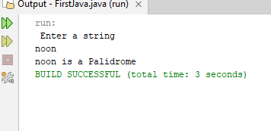

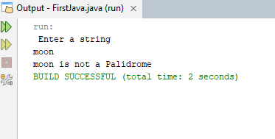

Question 5:
import java.util.Scanner;
public class FirstJava
{
public static void main(String[] args)
{
Scanner input = new Scanner(System.in);
System.out.println(" Enter a string ");
String word = input.nextLine();

int first = word.indexOf('h');
int last = word.lastIndexOf('h');
String result = "";
for(int i = 0; i < word.length(); i++)
{
char ch = word.charAt(i);

if(ch == 'h' && (i != first) && (i !=last))
result+='H';
else
result+=ch;
}
System.out.println(" The correct answer is " + result);
}
}

OUTPUT:
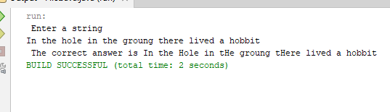

Question 6:
import java.util.Scanner;
public class FirstJava
{
public static void main(String[] args)
{
Scanner input = new Scanner(System.in);
System.out.println(" Enter a decimal number between 0 and 15");
int num = input.nextInt();
if(num<=15)
{
String hex = Integer.toHexString(num);
System.out.println(" The hex value is " + hex.toUpperCase());
}
else
{
System.out.println(num + " invalid input");
}

}

}

OUTPUT:
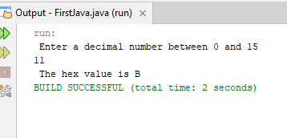

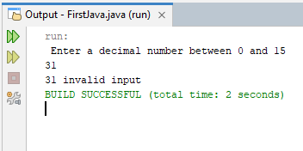

Question 7:
import java.util.Scanner;
public class FirstJava
{
public static void main(String[] args)
{
Scanner input = new Scanner(System.in);
System.out.println(" Enter a String");
String word = input.next();

System.out.println(word.charAt(2));

System.out.println(word.substring(1));

System.out.println(word.substring(0,5));
System.out.println(word.substring(0,3));

for(int i = 0; i < word.length(); i+=2)
{

System.out.print(word.charAt(i));
}
System.out.println();
for(int i = 1; i < word.length(); i+=2)
{

System.out.print(word.charAt(i));
}
System.out.println();
for(int i = 4; i >=0; i--)
{
System.out.print(word.charAt(i));
}
System.out.println();

for(int i = 4; i >=0; i-=2)
{
System.out.print(word.charAt(i));
}
System.out.println();

System.out.println(word.length());
}

}

OUTPUT:

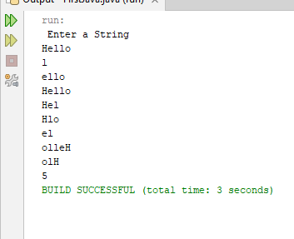

Question 8:
import java.util.Scanner;
public class FirstJava
{
public static void main(String[] args)
{
Scanner input = new Scanner(System.in);
System.out.println(" Enter a number");
int num = input.nextInt();
int count = 1;
int product;
while(count<=10)
{
product = num * count;
System.out.println( num + "*" + count + "= " + product);
count++;
}

}
}

Output:
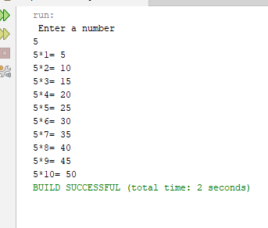

Question 9:
//import java.util.Scanner;
public class FirstJava
{
public static void main(String[] args)
{
int sum = 0;
for(int i =25; i <=60; i+=5)
{
sum+=i;
}
System.out.println(sum);

}
}

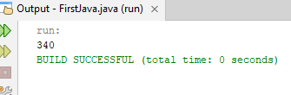
OUTPUT:

Question 10:
import java.util.Scanner;
public class FirstJava
{
public static void main(String[] args)
{
Scanner input = new Scanner(System.in);
System.out.println(" Enter a number");
int num = input.nextInt();
int sum = 0;
int square = 0;
for(int i =1; i <=num; i++)
{
square = i * i;
sum+=square;
}
System.out.println(sum);

}
}

OUTPUT:
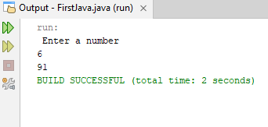

Question 11:
import java.util.Scanner;
public class FirstJava
{
public static void main(String[] args)
{
Scanner input = new Scanner(System.in);
System.out.println("Enter social security number ");
String num = input.nextLine();
boolean isValid = true;
for(int i = 0; i < 3; i++)
{
char ch = num.charAt(i);
if(!Character.isDigit(ch))
{
isValid = false;
break;
}
}

if(num.charAt(3) != '-' && num.charAt(6)!= '-' )
{
isValid = false;

}

for(int i = 4; i <6; i++)
{
char ch = num.charAt(i);
if(!Character.isDigit(ch))
{
isValid = false;
break;
}
}

for(int i = 7; i < 11; i++)
{
char ch = num.charAt(i);
if(!Character.isDigit(ch))
{
isValid = false;
break;
}
}
if(isValid)
System.out.println(" Valid number");
else
System.out.println(" Invalid Number");
}
}

OUTPUT:
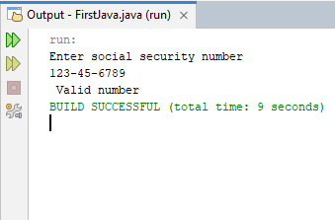

Question 12:
import java.util.Scanner;
public class FirstJava
{
public static void main(String[] args)
{
Scanner input = new Scanner(System.in);
System.out.println("Enter a number plate ");
String num = input.nextLine();
boolean isValid = true;
for(int i = 0; i < 3; i++)
{
char ch = num.charAt(i);
if(!Character.isUpperCase(ch))
{
isValid = false;
break;
}
}

for(int i = 3; i <7; i++)
{
char ch = num.charAt(i);
if(!Character.isDigit(ch))
{
isValid = false;
break;
}
}

if(isValid)
System.out.println(" Valid number");
else
System.out.println(" Invalid Number");

}
}

OUTPUT:

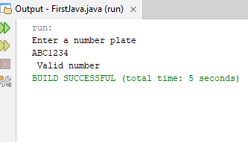

Question 13:
import java.util.Scanner;
public class FirstJava
{
public static void main(String[] args)
{
Scanner input = new Scanner(System.in);
System.out.println(" Enter a number");
int decNum = input.nextInt();
int answer = 0;
int power = 1;
while(decNum>0)
{
int rem = decNum%2;
decNum/=2;
answer+=(rem*power);
power*=10;
}
System.out.println(answer);

}
}

OUTPUT:

